Pupil premium strategy statement – Hamstead Primary School

This statement details our school’s use of pupil premium (and recovery premium) funding to help improve the attainment of our disadvantaged pupils.
It outlines our pupil premium strategy, how we intend to spend the funding in this academic year and the outcomes for disadvantaged pupils last academic year.

School overview
Detail | Data
Number of pupils in school | 390
Proportion (%) of pupil premium eligible pupils | 31.5%
Academic year/years that our current pupil premium strategy plan covers (3-year plans are recommended) | 2024/2025  2025/2026  2026/2027
Date this statement was published | November 2025
Date on which it will be reviewed | November 2026
Statement authorised by | Nicholas Fowler
Pupil premium lead | Sandeep Kaur
Governor | Lynn Howard

Funding overview
Detail | Amount
Pupil premium funding allocation this academic year | £186,345
Recovery premium funding allocation this academic year | £0
Pupil premium (and recovery premium*) funding carried forward from previous years (enter £0 if not applicable) | £0
Total budget for this academic year | £186,345

Part A: Pupil premium strategy plan

Statement of intent
When making decisions about using Pupil Premium funding it is important to consider the context of the school and the subsequent challenges faced. Research conducted by EEF should then be used to support decisions around the usefulness of different strategies and their value for money.
Our ultimate objectives are to:
- To narrow the attainment gap between disadvantaged and non-disadvantaged pupils.
- For all disadvantaged pupils in school to make or exceed nationally expected progress rates.
- To support our children’s health and wellbeing to enable them to access
learning at an appropriate level.
- Ensure disadvantaged pupils have access to resources to enable pupils to
access learning both at home and at school
- To provide enrichment activities for children

We aim to do this through:

- Ensuring that teaching and learning opportunities meet the needs of all the pupils
- Ensuring that appropriate provision is made for pupils who belong to vulnerable groups, this includes ensuring that the needs of socially disadvantaged pupils are adequately assessed and addressed
- When making provision for socially disadvantaged pupils, we recognise that not all pupils who receive free school meals will be socially disadvantaged
- We also recognise that not all pupils who are socially disadvantaged are registered or qualify for free school meals. We reserve the right to allocate the Pupil Premium funding to support any pupil or groups of pupils the school has legitimately identified as being socially disadvantaged.
- Pupil premium funding will be allocated following a needs analysis which will identify priority classes, groups or individuals. Limited funding and resources means that not all children receiving free school meals will be in receipt of pupil premium interventions at one time.

Achieving these objectives:
The range of provision the Governors consider making for this group include and would
not be inclusive of:

- Ensuring all quality first teaching is good or better thus ensuring that the quality of teaching experienced by all children is improved.
- Use of highly skilled LSPs/HLTA for early intervention and catch-up support across the school
- Additional teaching and learning opportunities and wider opportunities provided through trained school staff
- All our work through the pupil premium will be aimed at accelerating progress, moving children to at least age-related expectations.
- Support payment for activities, music tuition, educational visits and residentials. Ensuring children have first-hand experiences to use in their learning in the classroom.
- Attendance support

Challenges
This details the key challenges to achievement that we have identified among our disadvantaged pupils.
Challenge number | Detail of challenge
1 | Low attainment and slow progress rates made by pupil  premium/disadvantaged children.
2 | Limited opportunities for pupil premium/disadvantaged children to be heard reading (at home).
3 | Attainment gap of PP pupils in phonics, reading, writing and maths in all year groups.
4 | Pupils have limited experiences beyond their home life and immediate  community.
5 | Low attendance and persistent absenteeism of PP/disadvantaged  children.

Intended outcomes
This explains the outcomes we are aiming for by the end of our current strategy plan, and how we will measure whether they have been achieved.
Intended outcome | Success criteria
1. To close the gap in attainment for PP children compared to non-PP in all Year groups in R,W,M. | Attainment data shows that children are working in-line with their peers.
2. Year 1 PP children passing the phonics test | Achieve national average progress scores in Phonics
3.Year 2 PP children passing the resit | Number of children to resit = 8
4. Year 4 PP children MTC check – 20+ | 2025 = 16 children
5. To further enhance our Personal Development offer and provision in order to widen aspirations and choices for our pupils. | Visits, enrichment, clubs’ opportunities to be reviewed X3 visits per year group.  HPS Personal Development offer

Activity in this academic year
This details how we intend to spend our pupil premium (and recovery premium) funding this academic year to address the challenges listed above.

Teaching (for example, CPD, recruitment and retention)
Budgeted cost: £122, 465
Activity | Evidence that supports this approach | Challenge number(s) addressed
We will continue to focus on securing professional development over the 25/26 academic year to drive meaningful change.  Professional development directly links to the 25/26 School Development Plan.  Priorities for professional development include: - | School Development Plan  1) To further develop the consistency of curriculum approaches and outcomes  2) To embed maths mastery approaches across the whole school  3)To further strengthen inclusion  4)EYFS work with parents to support with Communication and Language outcomes. | 1,2,3,
Raise the profile of reading within school and develop the understanding of the close alignment between reading and writing. | Reading comprehension strategies are high impact +6 months. Alongside phonics it is a crucial component of early reading instruction.  Continue to work with the MG to deliver high quality phonics.  Exposing pupils to an increasingly wide range of texts, with an appropriate level of challenge, will develop their language capabilities. This should include active engagement with a wide range of genres and media. This variation is likely to be motivating and engaging and it provides an opportunity to explicitly teach the features and structures of different types of text. | 1,2,3
High quality teaching through adaptive/mastery teaching approaches.  Maths professional development – In line with mastery approach  Staff training, classroom observations, team-teaching opportunities. | - The best available evidence indicates that great teaching is the most important lever schools have to improve pupil attainment.  - • Pupils are likely to learn at different rates and to require different levels and types of support from teachers to succeed.  - • Adapting teaching in a responsive way, including by providing targeted support to pupils who are struggling, is likely to increase pupil success.  - • Seeking to understand pupils’ differences, including their different levels of prior knowledge and potential barriers to learning, is an essential part of teaching.  - • Support staff to stay for x3 staff meeting sessions over the year – linked to curriculum development | 1,2,3
Communication and language approaches – Early Talk Boost Interventions  (Nursery and Reception) | EEF +7 months  High quality provision is likely to include multiple strategies across vocabulary, language, talk and social communication skills. Overall, studies of communication and language approaches consistently show positive benefits for young children’s learning, including their spoken language skills, their expressive vocabulary and their early reading skills. | 1,2, 3
Early numeracy approaches – Mastering Number  (Reception) | EEF +7 months  While early numeracy approaches benefit all pupils, their impact on children from disadvantaged background tends to be higher. There is some evidence that targeted early numeracy approaches can help children from disadvantaged backgrounds catch up with their peers by the beginning of formal schooling. Early numeracy approaches have the potential to develop children’s knowledge and understanding of early mathematical concepts | 1, 3
Online platforms to support with high quality teaching | Ensuring every teacher is supported in delivering high-quality teaching is essential to achieving the best outcomes for all pupils, particularly the most disadvantaged among them. | 1,2,3
Teaching Assistant Interventions and CPD for support staff | EEF +4 months  Targeted deployment, where teaching assistants are trained to deliver an intervention to small groups or individuals has a higher impact. | 1,2,3
Small group tuition – in line with the adaptive teaching approach. | EEF +4 months  This involves a teacher working with up to five pupils. This intensive tuition approach is often provided to support lower attaining learners or those who are falling behind. Pre-teaching tasks where needed.  Small group tuition is most likely to be effective if it is targeted at pupils’ specific needs. | 1, 3
Peer tutoring – in line with the adaptive teaching approach. | EEF +5 months  Peer tutoring seems most effective when used to review or consolidate learning, rather than introducing new material. | 1,3
Whole class quality first teaching (phonics).  All staff to complete training using Little Wandle | Phonics tuition  EEF +5 months  Studies in England have shown that pupils eligible for free school meals typically receive similar or slightly greater benefit from phonics interventions and approaches. This is likely to be due to the explicit nature of the instruction and the intensive support provided.  It is possible that some disadvantaged pupils may not develop phonological awareness at the same rate as other pupils, having been exposed to fewer words spoken and books read in the home. Targeted phonics interventions may therefore improve decoding skills more quickly for pupils who have experienced these barriers to learning. | 1,2,3
Highly skilled LSPs/HLTA are timetabled to work with small groups and/or supporting classes alongside the class teacher. | EEF +2 months  EEF Small group tuition + 4 months  As the size of a class or teaching group gets smaller it is suggested that the range of approaches a teacher can employ and the amount of attention each student will receive will increase, improving outcomes for pupils.  Teaching assistants’ duties can vary widely, but they are generally deployed in two ways; to support the teacher in the general classroom environment, or to provide targeted interventions, which are often delivered out-of-class. | 1, 2
Reading- comprehension strategies | EEF +6 months  Reading comprehension strategies focus on the learners’ understanding of written text. Pupils learn a range of techniques which enable them to comprehend the meaning of what they read. These can include: inferring meaning from context; summarising or identifying key points. | 1,2,3
Feedback | EEF +6 months  Providing feedback is a well-evidenced and has a high impact on learning outcomes. Effective feedback tends to focus on the task, subject and self-regulation strategies: it provides specific information on how to improve. Feedback can be effective during, immediately after and sometime after learning. | 1, 3
Projected spend  £122,465 | Includes: Professional development training, support for early career teachers, recruitment and retention, small group tuition, subject development time, HLTA - Level 5 training, support staff training and recruitment, online platforms.

Targeted academic support (for example, tutoring, one-to-one support, structured interventions)
Budgeted cost: £37,000
Activity | Evidence that supports this approach | Challenge number(s) addressed
Lowest 20% of readers identified in all year groups. | Metacognition and self-regulation + 7 months  Metacognition and self-regulation approaches to teaching support pupils to think about their own learning more explicitly, often by teaching them specific strategies for planning, monitoring, and evaluating their learning.  Reading comprehension strategies + 6 months  Small group tuition + 4months feedback +6 months | 1, 2, 3
Teaching Assistant Interventions  -Phonics  -SULP  -Wellcomm  -Sandwell Numeracy/Literacy | EEF +4 months  Targeted deployment, where teaching assistants are trained to deliver an intervention to small groups or individuals has a higher impact. | 1,2,3
Teaching Assistant – supporting children with SEND/SEMH  SEND support Sunshine Room | Social and Emotional EEF +4 months  The majority of effective approaches involve targeted small group or one to one interventions. Impact in small groups tends to be a little lower (+3 months), but this needs to be offset against the greater number of pupils who benefit. | 1,2,3,4
Projected spend  £37,000 | Includes: HLTA am interventions, phonics interventions, Sunshine Room, SEND Support.

Wider strategies (for example, related to attendance, behaviour, wellbeing)
Budgeted cost: £26,880
Activity | Evidence that supports this approach | Challenge number(s) addressed
Attendance  -letters sent to parents.  -meetings with parents  -working closely with Attendance Officer (DT)  Rewards  -Half termly monitoring of attendance by Deputy Head teacher  Regular contact with families. | EEF Parental engagement +4 months  Parental engagement refers to teachers and schools involving parents in supporting their children’s academic learning. | 1,2,3,4,5
Pastoral/Early Help support | Behaviour +4 months  Behaviour interventions seek to improve attainment by reducing challenging behaviour in school. This entry covers interventions aimed at reducing a variety of behaviours, from low-level disruption to aggression, violence, bullying, substance abuse and general anti-social activities. | 1,2,3,4,5
School trips for disadvantaged pupils (subsidised)  -subsidy on trips and residential.  -subsidy for external visitors to enhance the curriculum (x1 RE visit per year group)  -Contribution towards whole school visitors / experiences | Outdoor adventure learning + 4 months  Arts + 3 months  Arts participation is defined as involvement in artistic and creative activities, such as dance, drama, music, painting, or sculpture – Flamenco workshop. | 4,5
Wellbeing sessions – to take place throughout the year for identified children.  Forest Schools  Welfare checks in the morning. | Social and emotional +4 months  Social and emotional learning (SEL) interventions seek to improve pupils’ decision-making skills, interaction with others and their self-management of emotions, rather than focusing directly on the academic or cognitive elements of learning. | 1,3,4,5
Bereavement support | Social and emotional +4 months  Social and emotional learning (SEL) interventions seek to improve pupils’ decision-making skills, interaction with others and their self-management of emotions, rather than focusing directly on the academic or cognitive elements of learning.  Behaviour +4 months | 1,2,3,4,5
Lunchtime supervision- supporting children who find it difficult during less structured parts of the day. | Social and emotional +4 months  - Self-regulation: teach children to use self-calming strategies and positive self-talk to help deal with intense emotions.  - Self-awareness: expand children’s emotional vocabulary and support them to express emotions. | 4
Children given a range of opportunities during and beyond the school day, including extracurricular activities, in order to build their cultural capital and increased opportunities for positive well-being activities. | Physical activity EEF (+1)  Physical activity has important benefits in terms of health, wellbeing and physical development. These benefits have important value in themselves as well as other potential benefits have been reported such as improved attendance. We believe that having these opportunities for our children is vitally important.
Parent workshops/information events  -Y6 SATs  -Phonics  -Y4 MTC  -Maths/Literacy  -School Readiness programme  -Parental reading engagement | EEF Parental engagement +4 months  Parental engagement refers to teachers and schools involving parents in supporting their children’s academic learning. It includes:  - approaches and programmes which aim to develop parental skills such as literacy or IT skills;  - general approaches which encourage parents to support their children with, for example reading or homework;  - the involvement of parents in their children’s learning activities; and  - more intensive programmes for families in crisis. | 1,2,3
Breakfast bagels + milk | It is important for pupils to start the day with a nutritious breakfast. Evidence shows that providing a healthy school breakfast at the start of the school day can contribute to improved readiness to learn, increased concentration, and improved wellbeing and behaviour.  The lack of studies identified that tested the NSBP mean that there is not enough security to communicate a month’s progress figure.  The National School Breakfast Programme (NSBP) aimed to provide free, nutritious and universally available breakfast in schools in disadvantaged areas of England.
Projected spend  £26,880 | Includes: Forest school, breakfast and milk, workshops, clubs, Wellbeing sessions, residential, behaviour/family support, attendance.
Uniform support
The lack of studies identified that tested school uniform approaches mean that there is not enough security to communicate a month’s progress figure. School uniform policies are often implemented alongside other improvement measures, which make it particularly challenging to measure the impact of uniform interventions alone.
There is a belief in some countries that school uniform supports the development of a whole school ethos and therefore supports discipline and motivation. Some also believe that a uniform promotes social equity. However, there is little robust evidence that introducing a school uniform will, by itself, improve academic performance, behaviour, or attendance.
There is a general belief in the UK that school uniform leads to improvements in pupils’ behaviour. It is important to remember that improved behaviour, on its own, does not necessarily lead to better learning, though it may be an important precondition.

Laptop support provided where needed- Geo books.
Total budgeted cost: £186,345
Pupil Premium Review 2025
The table shows the PP Gap over the 2024-25 academic year.
 |  | PP GAP
 | 2023 | 2024 | 2025 | Change
Y5 Reading | -13% | +10% | -3% | -13%
Y5 Writing | -4% | +4% | -2% | -6%
Y5 Maths | -7% | -6% | -8% | -2%
Y4 Reading | +4% | -3% | +5% | +8%
Y4 Writing | -2% | -1% | -3% | -2%
Y4 Maths | +2% | -8% | -1% | +7%
Y3 Reading | -17% | +6% | -15% | -21%
Y3 Writing | -23% | -3% | -22% | -18%
Y3 Maths | -21% | 0% | -24% | -24%
Y2 Reading | -43% | -15% | -6% | +9%
Y2 Writing | -45% | -9% | -8% | +1%
Y2 Maths | -51% | -23% | -7% | +16%
Y1 Reading | -13% | -9% | -8% | +1%
Y1 Writing | -25% | -16% | -4% | +12%
Y1 Maths | -7% | -4% | -6% | -2%

Reception |  | 2024 | 2025 | Change
All |  | 60 | 70 | +10%
PP |  | 80 | 50 | -30%
Non-PP |  | 57.7 | 72.5 | +14.8

Summary:
- Positive trends in PP attainment gaps – apart from Year 3.
- SK to look at individual children from assessment and arrange a meeting.
- Reception – Teaching staff changes. Support staff absences -impacted on interventions.
- Identify staff training needs

EYFS

EYFS | Good level of  development  SCHOOL | Good level of  development  LA
PP | 50% | 52%
Non-PP | 73% | 64%
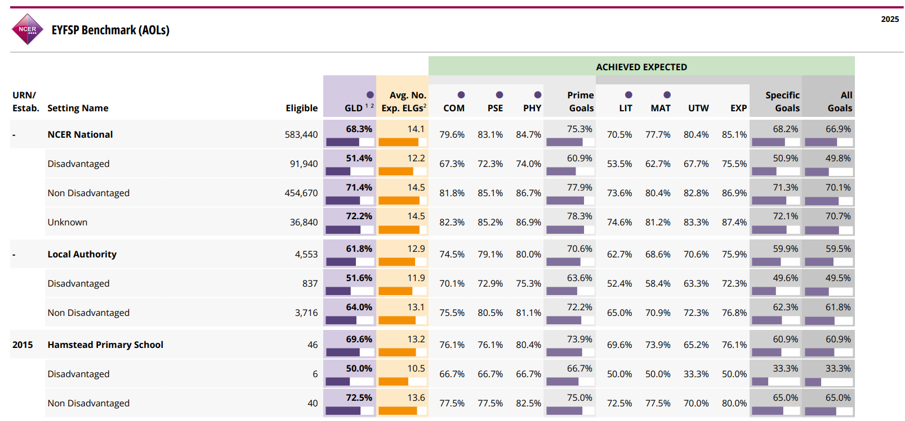

- Analysis of each Area of Learning and how this is planned for in the classroom.

Phonics

PHONICS Y1 | 2025
PP | 80%
Non-PP | 75%

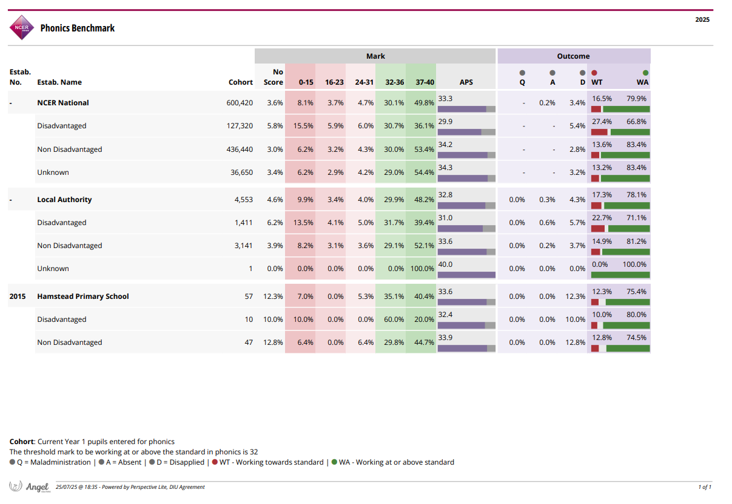
- Continue to work with MG (Phonics Hub)
Monitoring of phonics and feedback (NF and SK)
Staff training record

MTC Check
Y4 MTC update
All +20 | 42/59 71 %
All Y4 PP | 11/20 55 %
All Y4 Non-PP | 31/39 79 %

- 20 PP children -1 absent for testing window
-30% SEN
-Attendance issues identified

- Information shared with Y5 teachers to support
- Continue to use TT Rockstars
- Monitor and review progress
- Parent workshops

Year 6 SATs
Y6 SATs | 2024-2025  EXP+ | 2024-2025  GD
Reading PP | 59% | 29%
Reading Non-PP | 80% | 45%
Writing PP | 65% | 6%
Writing Non-PP | 80% | 10%
Maths PP | 59% | 18%
Maths Non-PP | 88% | 38%

- PP performing well in Reading and Writing, however Writing GD lower for PP children – this is a focus in school this year.

Attendance | Attendance continues to be monitored and followed up with meeting, letters and home visits.  - PP higher for unauthorised  - PP higher for Persistent absence – in line with LA (23.2%) we continue to work with families, send letters and home visits.
  For 2024-2025 | Attendance | Authorised Absence | Unauthorised Absence | Persistent absence
  All school | 94.7 | 3.2 | 2.0 | 15.2
  Pupil Premium Eligible | 93.3 | 3.8 | 2.8 | 23.3
  LA | 94.4 | 3.6 | 1.9 | 15.5
Trips/clubs | Have previously supported with payments.  -Guitars and Lego Therapy.  -Brilliant club 100% passed.  -Reviewing the HPS offer – outlining costs for parents

Intended outcome | Success criteria
1. To close the gap in attainment for PP children compared to non-PP in all Year groups in R,W,M. | Attainment data shows that children are working in-line with their peers.  See table page 10
2. Year 1 PP children passing the phonics test | Achieve national average progress scores in Phonics  2025  School = 75%  National = 78%
3.Year 2 PP children passing the resit | Number of children to resit = 19  8 children passed the resit
4. Year 4 PP children MTC check – 20+ | 2025 = 20 children  55% passed
5. To further enhance our Personal Development offer and provision in order to widen aspirations and choices for our pupils. | Visits, enrichment, clubs’ opportunities to be reviewed X3 visits per year group.  Percentage of children taking part in clubs (sports, guitar)  Continue to develop offer

